InternNova – Week 1 Assignment
Python Fundamentals

Task 1: Python Basics
Marks: 10

1. Brief Explanation
This program prints a welcome message and takes the student's name, college name, and branch as input. It then displays the entered information in a formatted output.

2. Python Source Code
print("Welcome to Python Fundamentals for Data Analytics!")

name = input("Enter your name: ")
college = input("Enter your college name: ")
branch = input("Enter your branch: ")

print("\n--- Student Information ---")
print(f"Name: {name}")
print(f"College: {college}")
print(f"Branch: {branch}")

3. Program Output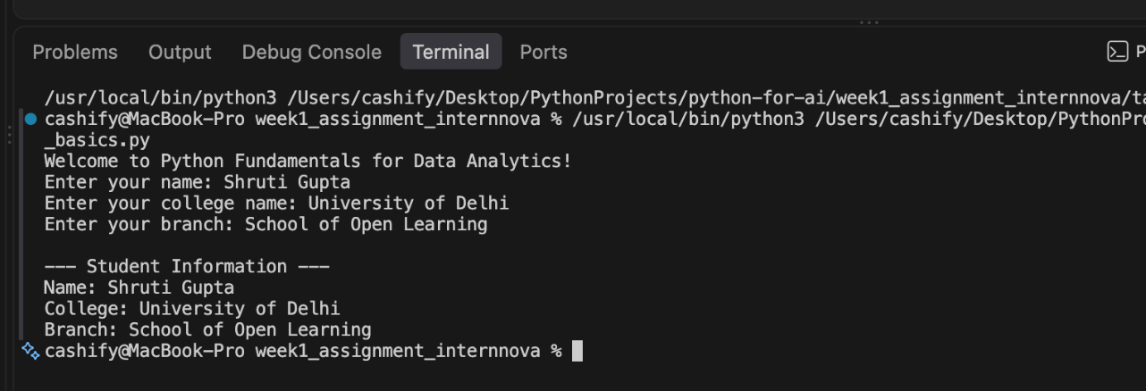

4. Conclusion
This task helped me understand the basic use of Python input and output statements. I learned how to take information from the user and display it in a clear and formatted manner. It also provided a basic understanding of Python programming and user interaction.

Task 2: Variables & Data Types
Marks: 10

1. Brief Explanation
This program demonstrates four basic Python data types: integer, float, string, and boolean. It stores values of each type in variables and uses the type() function to identify and display the data type of each value. A loop is used to print the value along with its corresponding data type in a clear format.

2. Python Source Code
integer_value = 25
float_value = 3.14
string_value = "Python"
boolean_value = True

values = [
("Integer", integer_value),
("Float", float_value),
("String", string_value),
("Boolean", boolean_value),
]

for label, value in values:
print(f"{label}: {value} | Type: {type(value).__name__}")

3. Program Output
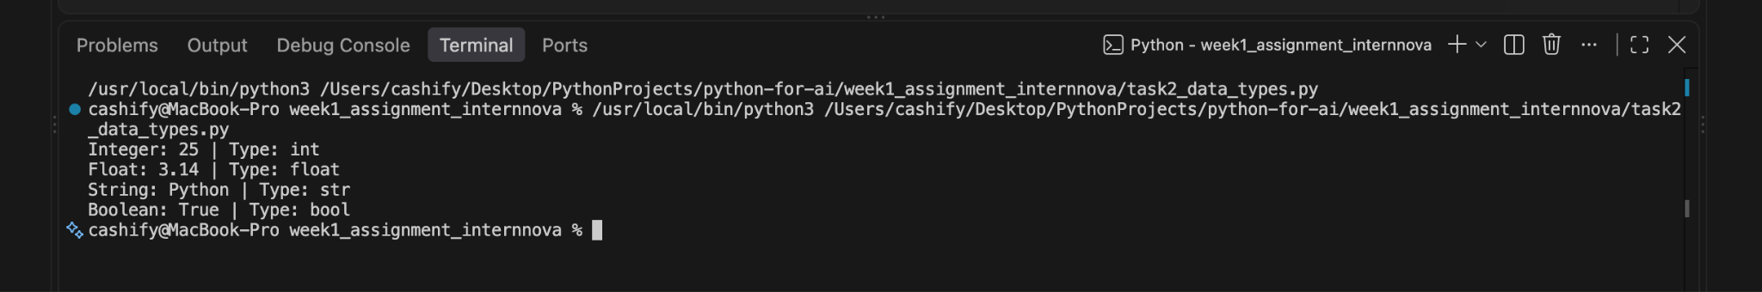

4. Conclusion
This task helped me understand the different basic data types in Python, including integers, floats, strings, and booleans. I also learned how to use the type() function to identify the data type of a value and how to use a loop to display the information in a clear and organized format.

Task 3: Operators
Marks: 10

1. Brief Explanation
This program works as a simple calculator that takes two numbers as input from the user. It performs five basic arithmetic operations: addition, subtraction, multiplication, division, and modulus. An if-else condition is used to handle division by zero and display an appropriate message instead of causing an error.

2. Python Source Code
first_number = float(input("Enter the first number: "))
second_number = float(input("Enter the second number: "))

print(f"Addition: {first_number + second_number}")
print(f"Subtraction: {first_number - second_number}")
print(f"Multiplication: {first_number * second_number}")

if second_number == 0:
print("Division: undefined (cannot divide by zero)")
print("Modulus: undefined (cannot divide by zero)")
else:
print(f"Division: {first_number / second_number}")
print(f"Modulus: {first_number % second_number}")

3. Program Output
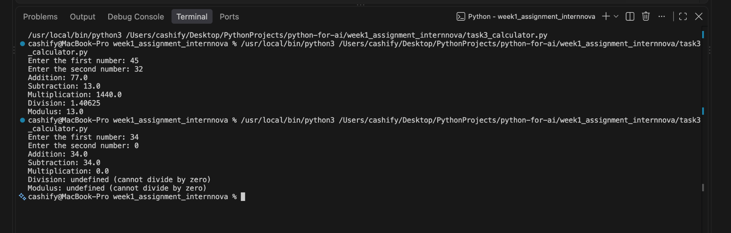

4. Conclusion
This task helped me understand how arithmetic operators are used in Python to perform calculations. I also learned how to take numerical input from the user and use conditional statements to handle special cases such as division by zero.

Task 4: Conditional Statements
Marks: 10

1. Brief Explanation
This program takes marks as input from the user and assigns a grade based on the given marks range. It uses if, elif, and else conditional statements to check different conditions. The program also validates the marks to ensure that the entered value is between 0 and 100.

2. Python Source Code
marks = float(input("Enter marks (0-100): "))

if marks < 0 or marks > 100:
print("Invalid marks. Enter a value from 0 to 100.")
elif marks >= 90:
print("Grade: A")
elif marks >= 75:
print("Grade: B")
elif marks >= 60:
print("Grade: C")
else:
print("Grade: Fail")

3. Program Output
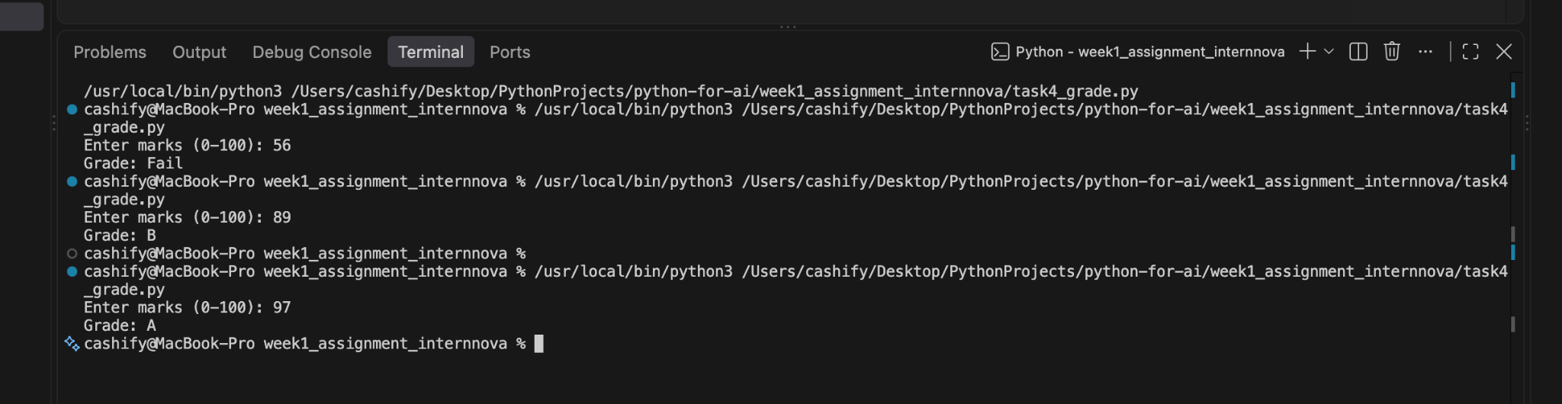
4. Conclusion
This task helped me understand how conditional statements can be used in Python to make decisions based on user input. I learned how to apply if, elif, and else to assign grades and how to handle invalid input using conditions.

Task 5: Loops
Marks: 10

1. Brief Explanation
This program demonstrates the use of for and while loops in Python. It uses a for loop to print numbers from 1 to 20 and to generate the multiplication table of a user-entered number. A while loop is used to print even numbers from 1 to 50. The program shows how loops can be used to repeat instructions efficiently.

2. Python Source Code
print("Numbers from 1 to 20:")
for number in range(1, 21):
print(number, end=" ")
print()

number = int(input("Enter a number for its multiplication table: "))
print(f"\nMultiplication table of {number}:")
for multiplier in range(1, 11):
print(f"{number} x {multiplier} = {number * multiplier}")

print("\nEven numbers from 1 to 50:")
even_number = 2
while even_number <= 50:
print(even_number, end=" ")
even_number += 2
print()

3. Program Output
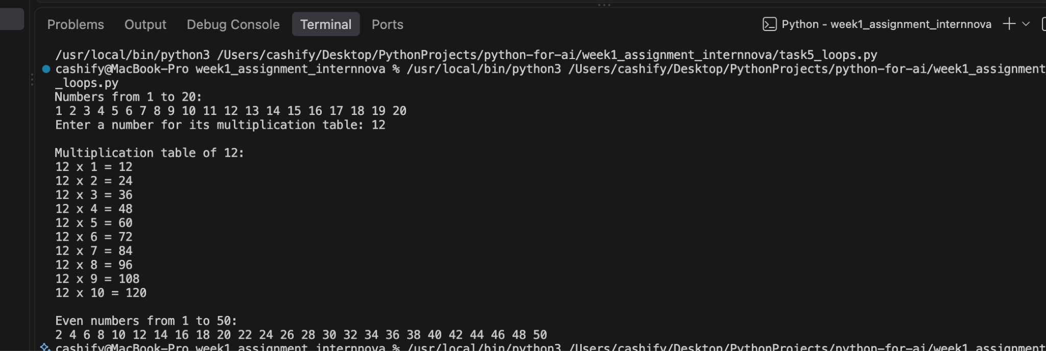

4. Conclusion
This task helped me understand how for and while loops are used in Python for repetitive tasks. I learned how to generate sequences of numbers, create a multiplication table, and print even numbers using loops.

Task 6: Functions
Marks: 10

1. Brief Explanation
This program demonstrates the use of user-defined functions in Python. It defines one function to calculate the square of a number and another function to calculate the average of three numbers. The program takes the required numbers as input from the user, calls the functions, and displays the calculated results.

2. Python Source Code
def square(number):
return number * number

def average(first_number, second_number, third_number):
return (first_number + second_number + third_number) / 3

number = float(input("Enter a number to square: "))
print(f"Square: {square(number)}")

numbers = [
float(input("Enter the first number for the average: ")),
float(input("Enter the second number for the average: ")),
float(input("Enter the third number for the average: ")),
]
print(f"Average: {average(*numbers)}")

3. Program Output
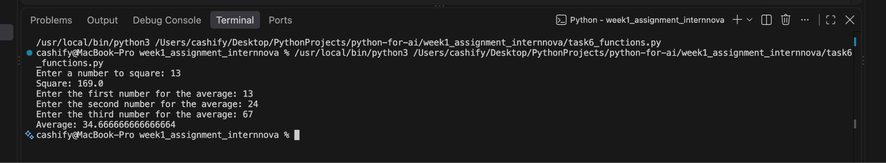

4. Conclusion
This task helped me understand how user-defined functions are created and used in Python. I learned how to pass values to functions, perform calculations, and return results. It also showed how functions can make a program more organized and reusable.

Task 7: Strings & Collections
Marks: 15

1. Brief Explanation
This program demonstrates different string and collection operations in Python. It uses upper(), lower(), replace(), and find() for string manipulation. It also demonstrates append(), remove(), and sort() on a list. A tuple is created and accessed using indexing, a dictionary is used to store student information, and a set is modified using add() and remove().

2. Python Source Code
text = "Python makes data analysis powerful"
print(f"Original string: {text}")
print(f"Uppercase: {text.upper()}")
print(f"Lowercase: {text.lower()}")
print(f"Replace: {text.replace('powerful', 'accessible')}")
print(f"Position of 'data': {text.find('data')}")

numbers = [30, 10, 20]
numbers.append(40)
numbers.remove(10)
numbers.sort()
print(f"\nList after append, remove, and sort: {numbers}")

student_tuple = ("Asha", "Computer Science", 21)
print(f"Tuple: {student_tuple}")
print(f"Tuple item at index 0: {student_tuple[0]}")

student = {"name": "Asha", "age": 21, "branch": "Computer Science"}
print(f"Student dictionary: {student}")

skills = {"Python", "SQL"}
skills.add("Excel")
skills.remove("SQL")
print(f"Set after add and remove: {skills}")

3. Program Output
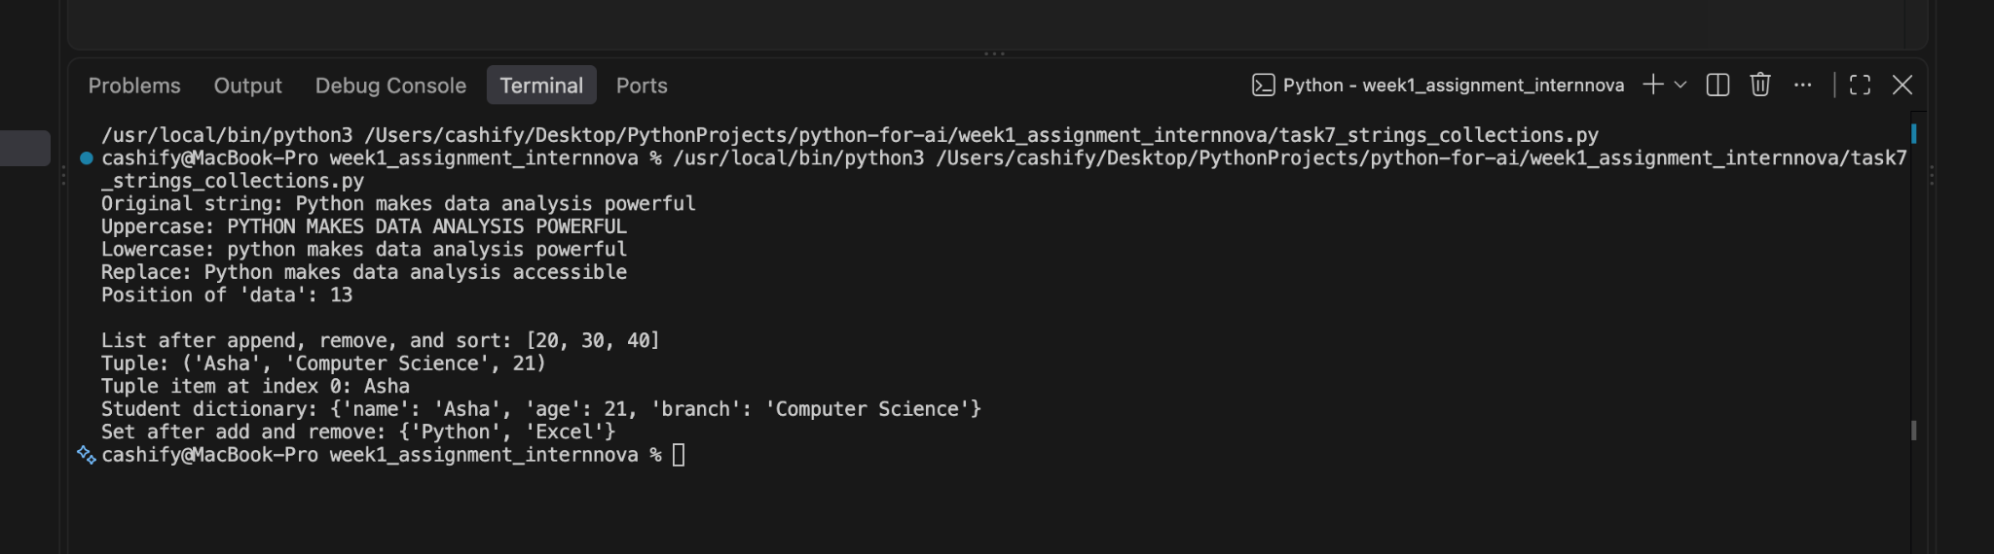

4. Conclusion
This task helped me understand how different collection types and string methods are used in Python. I learned how to manipulate strings and perform basic operations on lists, tuples, dictionaries, and sets. These concepts are useful for storing, organizing, and working with data efficiently.

Task 8: Basic File Handling
Marks: 10

1. Brief Explanation
This program demonstrates basic file handling in Python. It creates a text file named introduction.txt and writes a short introduction into the file. The program then opens the file in read mode, reads its contents, and displays the information on the screen.

2. Python Source Code
file_name = "introduction.txt"
introduction = (
"Hello, my name is Shruti. I am learning Python for Data Analytics.\n"
"Python helps me work with data and solve problems."
)

with open(file_name, "w", encoding="utf-8") as file:
file.write(introduction)

print(f"Created and wrote to {file_name}.")

with open(file_name, "r", encoding="utf-8") as file:
contents = file.read()

print("\nFile contents:")
print(contents)

3. Program Output
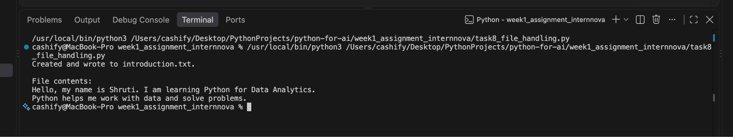

4. Conclusion
This task helped me understand the basic process of creating, writing, reading, and displaying the contents of a text file in Python. I also learned how to use the with open() statement for handling files efficiently.

Task 9: Mini Python Project
Marks: 15

1. Brief Explanation

This project is a menu-driven Student Record Management System developed using Python. It stores student details in a list of dictionaries and provides options to add, display, search, and delete student records. Separate functions are used for each operation, making the program organized and easy to manage.

2. Python Source Code

students = []

def add_student():
name = input("Enter student name: ").strip()
age = input("Enter student age: ").strip()
branch = input("Enter student branch: ").strip()
students.append({"name": name, "age": age, "branch": branch})
print("Student added successfully.")

def display_students():
if not students:
print("No student records found.")
return

print("\n--- Student Records ---")
for index, student in enumerate(students, start=1):
print(
f"{index}. Name: {student['name']}, "
f"Age: {student['age']}, Branch: {student['branch']}"
)

def search_student():
search_name = input("Enter the name to search: ").strip().lower()
matches = [
student for student in students
if search_name in student["name"].lower()
]

if not matches:
print("Student not found.")
return

for student in matches:
print(
f"Name: {student['name']}, "
f"Age: {student['age']}, Branch: {student['branch']}"
)

def delete_student():
delete_name = input("Enter the name to delete: ").strip().lower()
for index, student in enumerate(students):
if student["name"].lower() == delete_name:
students.pop(index)
print("Student deleted successfully.")
return
print("Student not found.")

def main():
while True:
print("\nStudent Record Management System")
print("1. Add student")
print("2. Display all students")
print("3. Search student")
print("4. Delete student")
print("5. Exit")
choice = input("Enter your choice: ").strip()

if choice == "1":
add_student()
elif choice == "2":
display_students()
elif choice == "3":
search_student()
elif choice == "4":
delete_student()
elif choice == "5":
print("Goodbye!")
break
else:
print("Invalid choice. Please select 1 to 5.")

if __name__ == "__main__":
main()

3. Program Output
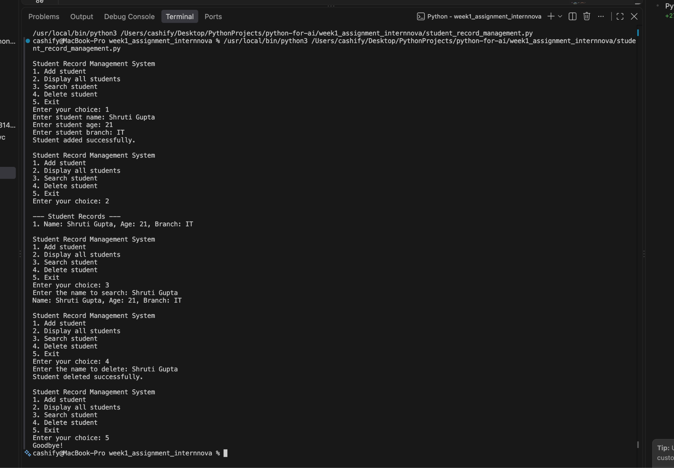

4. Conclusion
This project helped me apply the Python concepts learned throughout the week in a practical program. I used lists, dictionaries, functions, loops, conditional statements, and user input to create a simple student record management system. It improved my understanding of how different Python concepts can be combined to solve a practical problem.

